**Creating iPSC lines with Ribonucleoprotein (RNP):**

**Nucleofection, Single-cell Sorting, Genotyping, and Line Maintenance Protocol**

**Kamaljot Gill1,2, Aradhana Sachdev2, Bruce Conklin2, Claire Clelland*1,2,3**

Affiliations:

1. University of California, San Francisco, Weill Institute for Neurosciences, USA
2. Gladstone Institutes, San Francisco, CA, USA
3. Department of Neurology, University of California, San Francisco, San Francisco, CA, USA *Contact: claire.clelland@ucsf.edu

This protocol describes how to perform gene editing on human induced pluripotent stem cells (iPSCs) via ribonucleoprotein (RNP) and how to the isolate lines with the desired excision. It describes nucleofection, single cell sorting via FACS, genotyping, and the maintenance of the cell lines throughout the process. This protocol is optimized for spCas9.

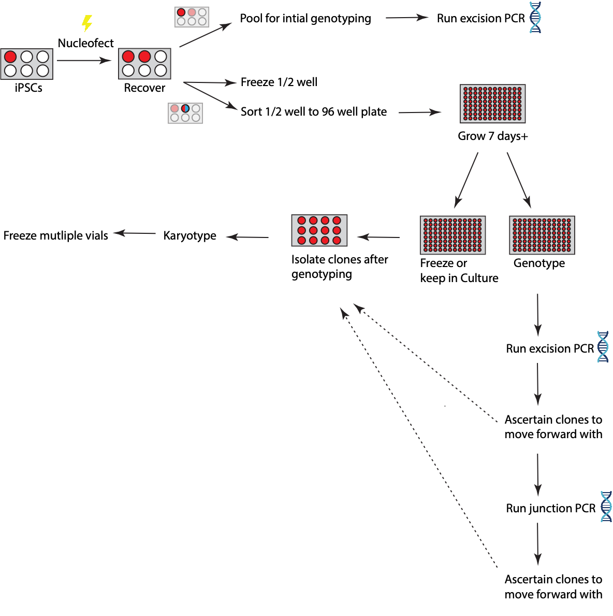

**Figure 1: Schematic describing the flow of steps in creating iPSC cell lines with RNP**

# Nucleofecting

1. Cell Culture
   1. Grow iPSCs in 1 well of a 6 well-plate until ~70-80% confluency
      1. At this confluency in a 6 well-plate, there should be at least 1.5 million cells
2. Coating plates
   1. Coat 1 x 6 well-plate with Matrigel
      1. Matrigel is diluted in KO DMEM to make a working concentration of 80 µg/mL (keep the Matrigel ice-cold)
      2. Matrigel coating volumes
         1. 6 well plate: 1 mL
         2. 12 well plate: 0.5 mL
         3. 24 well plate: 0.25 mL
         4. 48 well plate 0.125 mL 5. 96 well plate: 0.100 mL
   2. Incubate the plate at 37°C for 30 minutes
3. Turn on the Lonza 4D-Nucleofector
4. Prepare Media
   1. For 20mL:
      1. 18 mL mTeSR Plus
      2. 2 mL Clone R (10X)
      3. 20 µL of 10mM ROCK Inhibitor (RI)
5. Prepare P3 Buffer
   1. For 12 reactions (250 µL) in a 16 well nucleofector strip
      1. 45.45 µL Nucleofector™ Supplement
      2. 204.54 µL Nucleofector™ Solution
   2. Place on ice
      1. Once made, you may store the P3 buffer at 4°C for up to 3 months
6. Reconstitute 1.5 nmol sgRNA in a BSC
   1. Add 15 µL TE buffer to make 100 µM sgRNA
   2. Store -20°C for long term storage
7. Prepare RNP
   1. For each nucleofection, mix a ratio of 1:3 (spCas9:guide) **sgRNA (50 µM) = .6 µL, spCas9 (20 µM) = .5 µL**
   2. Incubate RNPs at room temperature for 10-15 mins
8. Prepare cells (1 well)
   1. Wash the well with PBS
   2. Detach cells from plate with Accutase
      1. Incubate cells in 0.5 mL Accutase. Incubate the plate for 10-15 mins at

37°C. Quench the Accutase with 2.5 mL of PBS ii. Transfer media into a 15 mL conical tube iii. Spin down the cells in a 15 mL conical for 3 mins at 800 rpm iv. Remove supernatant

* + 1. Resuspend the cells in 1-2 mL of warm media
    2. NOTE: We use Accutase to obtain single cells
  1. Count cells
  2. Transfer ~350k cells in an Eppendorf tube (per reaction)

1. Prepare reaction
   1. Centrifuge the cells at 800 rpm for 3 mins. Aspirate supernatant.
   2. Resuspend pellet in 20 µL of P3 buffer
   3. Add 1 µL of RNP (Cas9+sgRNA) to the Eppendorf tube
      1. If using two different RNPs, only add .5 µL of each because only half of each RNP is needed
   4. Transfer each sample to one well of a 16 strip nucleofector cuvette/strip. Check lid to make sure it is in the correct orientation
   5. Tap nucleofector strip on a surface to distribute sample and pop any bubbles
      1. If needed, use a P20 pipette tip to gently pop any bubbles
2. Nucleofecting
   1. Set up the reaction on 4D-Nucleofector Core X - Unit
      1. Select wells being used in your strip
      2. Select P3 buffer setting
      3. Select 16-well strip
      4. Select Pulse Code = DS138
   2. Place the nucleofector strip in the nucleofector and hit start
   3. Green plus sign should appear if reaction is successful
3. Place the nucleofector strip in the hood (do not spray it with EtOH) and incubate at room temperature for 5-10 mins
4. Prepare plate
   1. Obtain the 6 well-plate that was coated with Matrigel earlier
   2. Aspirate Matrigel
   3. Replace with 2 mL of media
5. Recover Cells
   1. Add 80 µL of media to each well of the nucleofector strip to recover the cells
   2. Slowly pipette up and down to ensure cells are properly dispersed
6. Transfer cells to plate
   1. For each nucleofection, transfer 50 µL/well of the cells to 2 wells of a 6 well-plate
   2. Gently rock the plate and incubate overnight at 37°C
7. Maintain cells
   1. Grow the cells until they are 70-80% confluency (approximately 3-4 days)
   2. When cells are at 70-80% confluency, you may
      1. Harvest one well for sorting
      2. Harvest one well for freezing and genotyping (lift the well and pellet into 2 separate conical tubes)

# Harvesting Cells for Freezing and Genotyping

1. At 70-80% confluency, collect the pooled population of cells
   1. Incubate cells in 0.5 mL Accutase. Incubate the plate for ~5-10 mins at 37°C
   2. Quench the Accutase with 2.5 mL of PBS
   3. Transport 1.5 mL/conical tube of the cells to 2 x 15 mL conical tube
   4. Spin down the cells at 800 rpm for 3 mins
   5. Aspirate the supernatant
2. Freezing the pool
   1. Resuspend one of the pellets in 1mL of ice-cold CryoStor
   2. Transfer cells into a cryovial
   3. Transport vial to a Mr. Frosty with 2-propanol
   4. Place Mr. Frosty at -80°C to freeze for 24 hours

i. After 24-48 hours, move the vial to liquid nitrogen

1. Genotyping pool (go to the Genotyping section for more information)
   1. Store the remaining pellet in the conical tube at -20°C until ready to extract DNA
   2. Perform an excision PCR with an unedited line as a negative control
   3. NOTE: This is an important check that can save you time later on. Genotyping the pool informs you that you have any excision in any cells.

# Single Cell Sorting by FACS

1. Preparing a 96 well-plate
   * 1. Coat a 96 well-plate with 100 µL/well of Matrigel.
     2. Allow the plate to incubate with Matrigel for at least 30 mins at 37°C.
     3. Prepare 20 mL of Media (mTeSR Plus + RI (1,000X) + Clone R (10X) + Anti-Anti

(100X))

* + - * 1. 18 mL mTeSR Plus
        2. 2 mL of CloneR (10X)
        3. 200 µL of Anti-Anti (100X)
        4. 20 µL of 10 mM RI
        5. NOTE: If using alternative media, it must NOT be more than 2% FBS
    1. Aspirate the Matrigel from the 96 well-plate and add 100 µL/well of media to each well
    2. Set the plate back into the incubator.

1. Preparing Cells
   * 1. Wash the well with PBS.
     2. Add 0.5 mL Accutase.
     3. Incubate the plate for ~10-15 mins at 37°C
     4. Quench the Accutase with 2.5 mL of PBS
     5. Transport cells into a 15 mL conical tube
     6. Spin down the cells for 3 mins at 800 rpm
     7. Remove supernatant
     8. Resuspend the cells in 1-2 mL of warm media
     9. Count cells
     10. Dilute cells to a 1.5 million cells/500 µL

i. NOTE: For single - sorting, 1.5 million cells in 500 µL of media is an appropriate concentration

k. Pass cells through a filter mesh (strainer cap) using a P1000

* + - 1. Place a filter mesh on top of a FACS collection tube
      2. Replace filter mesh with cap for collection tube
      3. NOTE: You can directly press the tip against the mesh and pipette the cell solution into the collection tube

1. Transport cells to FACS machine
   1. Seal the 96 well-plates with media with parafilm
   2. Seal the collection tube with parafilm
   3. Clean a large container with ethanol
   4. Place the 96 well-plate and collection tube into the container
2. FAC Sorting
   1. Perform single cell sorting with aBD FACS Aria Fusion (Beckton Dickinson), equipped with 355, 405, 488, 561 and 640 nm lasers.

i. The QC alignment of each laser should be verified with Cytometer Setup and Tracking Beads (Becton Dickinson) before sample acquisition.

* 1. Set forward a scatter threshold of 15,000 to eliminate debris from list mode data, and fix the number of events to be collected.
  2. In certain experiments mCherry fluorescence (excitation 561 nm, emission 610 nm) can be used to define sorting parameters.
  3. Drop delay determination and 96 well plate set-up setup using Accudrop beads (Becton Dickinson).
  4. Use forward scatter area versus height and side scatter area versus height gates to make the single cell determination. The specifications of the sort layout include single cell precision, 96 well collection device and target event of 1.

1. Quarantining Cells: Day 0
   1. Move cells to the quarantine incubator (or a separate incubator from other cell lines) during the duration of 7-day Anti-Anti treatment and before confirming that the cells are mycoplasma negative

i. Perform a mycoplasma test between Day 3 and Day 7

1. Days 1-3
   1. Do not change media
   2. Ensure there is 1 cell/well and there is no contamination.

i. NOTE: Cells will be hard to see for the first few days. ii. NOTE: Expect a ~40% cell survival for single cells

1. Day 4
   1. Prepare fresh media without ROCK inhibitor. For 12 mL
      * + 1. 10.8 mL mTeSR Plus
          2. 1.2 mL Clone R (10x)
          3. 120 µL Anti-Anti (100x)
      1. Aspirate spent media using a multichannel aspirator
      2. Pipette 100 µL/ well of the new media into each well of a 96 well-plate

i. NOTE: Be careful not to cross contaminate. These are individual clones.

* + 1. Check there is 1 colony/well. Ensure colonies are growing.

1. Day 6

a. Prepare fresh media without ROCK inhibitor and Clone R. For 12 mL:

* + - * 1. 12 mL mTeSR Plus
        2. 120 µL Anti-Anti (100x)
    1. Aspirate spent media using a multichannel aspirator
    2. Pipette 100 µL/ well of the new media into each well of a 96 well-plate

i. NOTE: Be careful not to cross contaminate. These are individual clones.

* + 1. Check there is 1 colony/well. Ensure colonies are growing
    2. Perform a mycoplasma test during this stage or earlier

1. Day 8 on
   * 1. If the cells are 70-80% confluent or begin to grow on top of each other, **move onto the next step**. If not, continue with this step.
     2. If the cells are not ready, continuing feeding but with just mTeSR Plus
        + 1. Aspirate spent media using a multichannel aspirator
          2. Pipette 100 µL/ well of mTeSR Plus into each well of a 96 well-plate

1. NOTE: Be careful not to cross contaminate. These are individual clones.

iii. Check there is 1 colony/well. Ensure colonies are growing

c. Keep cells in 96 well-plate for 1-7 more days or until the clones can be passaged to a smaller plate format

# Passaging and Maintaining the Clones

1. Identify the surviving clones
   * 1. Using a microscope and marker, count and label the wells of the 96 well-plate where there are surviving clones
     2. If there are between 24 and 48 clones, then you will passage the cells in 2 x 48 well-plates

i. One plate is to keep the clone in culture and the other plate is for genotyping

c. If there are less than 24 clones, then you will passage the cells into 2 x 24- wellplates

i. One plate is to keep the clone in culture and the other plate is for genotyping

1. Prepare the 24 or 48 well-plates
   1. Matrigel coat the 24 or 48 well-plates
   2. Incubate for at least 30 minutes at 37°C
   3. Prepare media. For 25 mL:
      * 1. 25 mL mTeSR Plus
        2. 25 µL of 10mM RI
   4. Aspirate the Matrigel from plates
   5. Add media to plates

i. For 48 well-plates: add 250 µL/well ii. For 24 well-plates: add 500 µL/well

1. Clump passage the clones (row-by-row)
   1. Aspirate spent media from one row of the 96 well-plates
   2. Pipette 50 µL/well of ReLeSR
   3. Incubate at room temperature for 45 seconds
   4. Aspirate ReLeSR from cells
   5. Incubate the 96 well-plate at 37°C for 3 minutes
   6. Pipette 100 µL/well of mTeSR Plus w/ ROCK inhibitor to each well in the row
   7. Resuspend cells by pipetting up and down
   8. Move 35 µL into one well of the new plates and 65 µL into another well of the other new plate
   9. NOTE: Be sure that you pipette into the same pattern to ensure the 2 plates are identical

ii. NOTE: It is possible to add more cells to one plate than the other to harvest the more confluent plate first.

* 1. Once a row is passaged, disperse the cells by rocking in all four directions
  2. Continue row-by-row until the entire plate is passaged

1. Day 1 post passaging
   1. NOTE: Most of the time, at least one plate will be 70-80% confluent the next day. This plate can be harvested for genotyping. The other plate may be a little less confluent and should can be maintained until it is 70-80% confluent (usually the day after)
   2. NOTE: Genotyping (at least performing the excision PCR) can occur within the day and the clones with the preferred edit can be identified.
   3. If one plate is at least 70-80% confluent, move to the next step. Otherwise, maintain the plates.
2. Harvesting one plate to genotype the clones
   1. Aspirate the spent media
   2. Wash the cells with 200 µL/well of PBS
   3. Aspirate the PBS
   4. Seal the sides of the plate with parafilm to avoid evaporation
   5. Store the plate at -20°C and harvest DNA later or extract DNA immediately using

Quick Extract

* 1. Quick Extract Protocol

i. Add 50 µL/well of Quick Extract ii. Scrape the bottom of the well to detach cells *Note*: Time can be saved by performing the above steps to the entire row before moving to the steps below (one row at a time) iii. Mix by vortexing for 15 seconds iv. Transfer cells in Quick Extract to labeled PCR tubes.

*Note*: If the QE is very viscous at this step, use more QE to obtain a more fluid consistency

* + - * 1. Incubate the samples at 65°C for 6 minutes using a Thermocycler
        2. Mix by vortexing
        3. Incubate the samples at 98°C for 2 minutes using a Thermocycler

1. (Optional) Freezing the clones
   * 1. NOTE: There is a probability that some clones will be lost via the freezing and thawing process
     2. Obtain a Styrofoam box and clean it with ethanol
     3. Grow the plate until clones are 70-80% confluent
     4. Aspirate spent media
     5. Wash cells with 200 µL/well of PBS. Aspirate
     6. Add 100 µL/well of ReLeSR.
     7. Incubate at RT for 45 seconds
     8. Aspirate and incubate plate at 37°C for 3 mins
     9. Add CryoStor
        1. For 96 well-plates: 100 µL/well ii. For 48 well-plates: 200 µL/well
        2. Add Mineral Oil

i. For 96 well-plates: 100 µL/well ii. For 48 well-plates: 200 µL/well

* + 1. Seal the plate with parafilm
    2. Place the plate in the Styrofoam box
    3. Carefully transfer the box to a -80°C freezer
    4. The cells are stable for up to 1 month at -80°C

1. (Optional) Thawing clones from frozen 96/48-well plate

a. Coat 12 well plates with 0.5 mL/well of Matrigel

i. Incubate the plate at 37°C for at least 30 minutes

* + 1. Label Eppendorf tubes with the clone number of the clones that you will move forward with
    2. Prepare Media. For 12 mL:
       - 1. 12 mL mTeSR Plus
         2. 12 µL of 10 mM ROCK inhibitor
    3. Warm PBS to 37°C
    4. Place the frozen plate on paper towels and place it in the 37°C incubator for 10 minutes or until edges of the plate are thawed
    5. Pipette warm PBS onto wells that you want to thaw
    6. Pipette the cells into their respective Eppendorf tube
    7. Centrifuge at 800 rpm for 3 mins
    8. Aspirate the supernatant

*Note*: Pellet will be too small to visualize, but it is there!

* + 1. Resuspend the pellet in 1mL of media
    2. Pipette the cells into 1 well of a 12 well-plate
    3. Place plate in incubator

# Genotyping

*Note*: In order to save time and reagents, it is recommended to perform genotyping in various stages and reduce the total number of potential clones throughout the process.

Specifically, perform the excision PCR on all the clones, then only perform 5’ and 3’ cut site PCR on clones that have the correct excision band. Likewise, only maintain clones which pass the various genotyping stages.

*Note*: You may design and manage the primers using a various set of resources, but the following tools are recommended:

* Obtaining gene sequences: National Center for Biotechnology Information (https://www.ncbi.nlm.nih.gov/)
* Storing and aligning sequences: SnapGene
* Designing primers: Primer Blast (https://www.ncbi.nlm.nih.gov/tools/primer-blast/)
* Ordering primers: Integrated DNA Technologies (www.idtdna.com/) o !"#$%&’()*+$),-"./&-()0)1%(’#2)345)67/8#()0)345)67/8#()9#"$-")+#:;
* Check for off targets: Basic Local Alignment Search Tool

(https://blast.ncbi.nlm.nih.gov/Blast.cgi)

**Steps**

1. Perform an excision PCR (perform on all clones)
   1. Designing excision primers
      1. These set of primers should bind outside of both of the cut sites
      2. Length: After the excision, the expected length of the band should be between 100 bp and 1000 bp
   2. Expectations
      1. Unedited line: A large band or no band because of the size of the excision
      2. Homozygous excision: Expected band size
      3. Heterozygous excision: Expected band size and the unedited band

(unless there is no band)

* 1. Sanger Sequence
     1. Save some PCR product to sanger sequence at a later time

1. Perform 5’ cut site excision PCR (perform only on clones that have the correct excision band)
   1. Design 5’ cut site primers
      1. One of the primers should bind on the 5’ outside of the cut site and the other primer should bind within the excision region
      2. Length: If the excision did not occur, the expected length of the band should be between 100 bp and 1000 bp. With the excision, we expect no bands
   2. Expectations
      1. Unedited line: Expected band size
      2. Homozygous excision: No band
      3. Heterozygous excision: Expected band size
2. Perform 3’ cut site excision PCR (perform only on clones that have the correct excision band)
   1. Design 3’ cut site primers
      1. One of the primers should bind 3’ outside of the cut site and the other primer should bind within the excision region
      2. Length: If the excision did not occur, the expected length of the band should be between 100 bp and 1000 bp. With the excision, we expect no bands
   2. Expectations
      1. Unedited line: Expected band size
      2. Homozygous excision: No band iii. Heterozygous excision: Expected band size

# Karyotyping and Freezing

1. Send one or two clones with correct excisions to karyotype

a. Freeze a few vials (3-4) of all clones you are karyotyping

1. Expand and freeze 10+ vials of the clone with the correct excision and normal karyotype

**Reagents used:**

|  |  |  |
| --- | --- | --- |
| **Reagent** | **Manufacturer** | **Catalog #** |
| P3 Primary Cell 96-well Nucleofector™ Kit (96 RCT) | Lonza | V4SP-3096 |
| ReLeSR™ | STEMCELL | 05872 |
| PBS, pH 7.4 | ThermoFisher | 10010023 |
| Accutase™ | STEMCELL | 07920 |
| mTeSR™ Plus | STEMCELL | 100-0276 |
| CloneR™ | STEMCELL | 05888 |
| KnockOut™ DMEM | ThermoFisher | 10829018 |
| Corning® Matrigel® Growth Factor Reduced (GFR) Basement Membrane Matrix, Phenol Red-free, LDEVfree, 10 mL | Corning | 356231 |
| CryoStor® CS10 | STEMCELL | 07930 |
| QuickExtract™ DNA Extraction Solution | Lucigen | QE09050 |
| Antibiotic-Antimycotic (100X) | ThermoFisher | 15240062 |
| ROCK Inhibitor (Y-27632 2HCl) | Selleckchem | S1049 |
| Olympus Plastics 28-154, 35µm Strainer Caps | Genesee | 28-155 |
| 2-Propanol | Sigma | 190764-4L |
| Mineral Oil | Sigma | M8410-100ML |
| Cas9-NLS Purified Protein | QB3 MacroLab |  |

**Equipment used:**

|  |  |  |
| --- | --- | --- |
| **Equipment** | **Manufacturer** | **Catalog #** |
| 4D-Nucleofector Core Unit | Lonza | AAF-1002B |
| 4D-Nucleofector X Unit | Lonza | AAF-1002X |
| BD FACS Aria Fusion | Beckton Dickinson |  |
| Mr. Frosty™ Freezing Container | ThermoFisher | 5100-0001 |
| Costar® vacuum aspirator | MilliporeSigma | CLS4931 |